|  |  |
| --- | --- |
|  | Google key phrase research template |

Turn on Privacy mode in your web browser. As you type words into Google, it will suggest popular search terms in the drop down. Write these down before you click away. Then type them in individually, to see how many results come up for them. **Tip:** click Tools to see the number of search results:

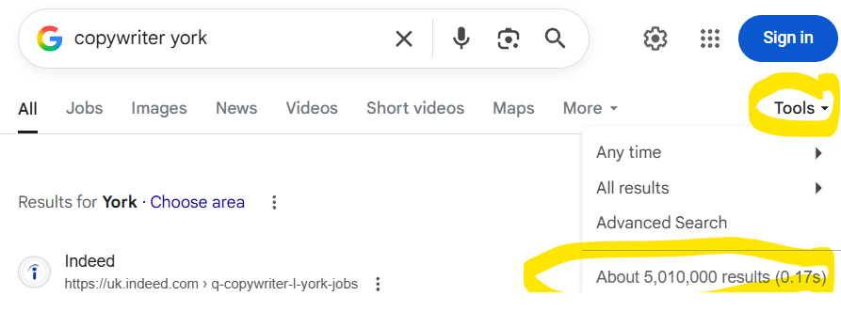

You want the Goldilocks spot of not too many but not too few. I aim for 2 – 5 million results if possible. Too few (under a million) means too niche. But it of course depends on your sector/competition.

|  |  |
| --- | --- |
| **Search key phrase** | **Number of Google search results** |
|  |  |
|  |  |
|  |  |
|  |  |
|  |  |
|  |  |
|  |  |
|  |  |
|  |  |
|  |  |
|  |  |
| **Search key phrase** | **Number of Google search results** |
|  |  |
|  |  |
|  |  |
|  |  |
|  |  |
|  |  |
|  |  |
|  |  |
|  |  |
|  |  |
|  |  |
|  |  |
|  |  |
|  |  |
|  |  |
|  |  |
|  |  |

Still struggling to find something? Try [AnswerThePublic.com](https://answerthepublic.com/) to see what people are looking for. You could also try:

* Adding a sector or specialism to the end of the search term
* Adding a town or region to the end of the search term
* Swapping out jargon for a more everyday term
* Rephrasing it as a question